Module 02 Activity – Working with Data

Tracy Brevig

Rasmussen College

COURSE#: W110/COP1801 Section 01 Javascript

Instructor’s Name: Kimberly Powell

February 19, 2021

**Screenshots of the loaded pages:**

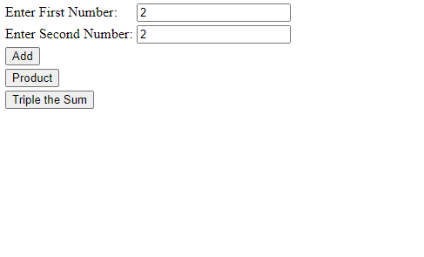

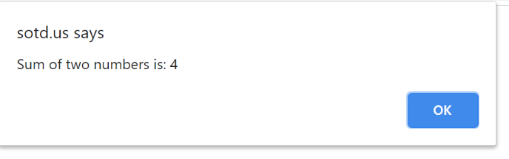

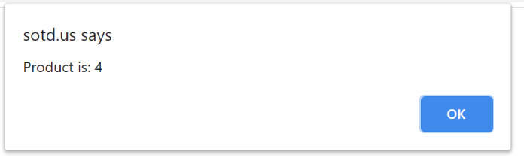

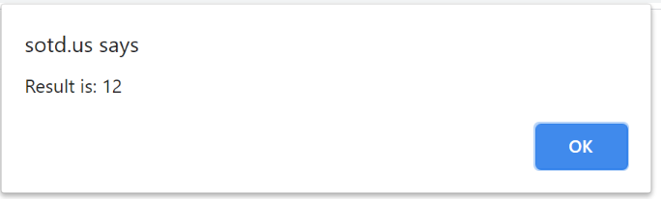

URL Link

<http://sotd.us/tracybrevig/index2.html>